The **Curriculum Mapping** pilot can be access by visiting the following URL: <http://mapping.mimas.ac.uk>

Upon visiting this URL you will be prompted to log in.

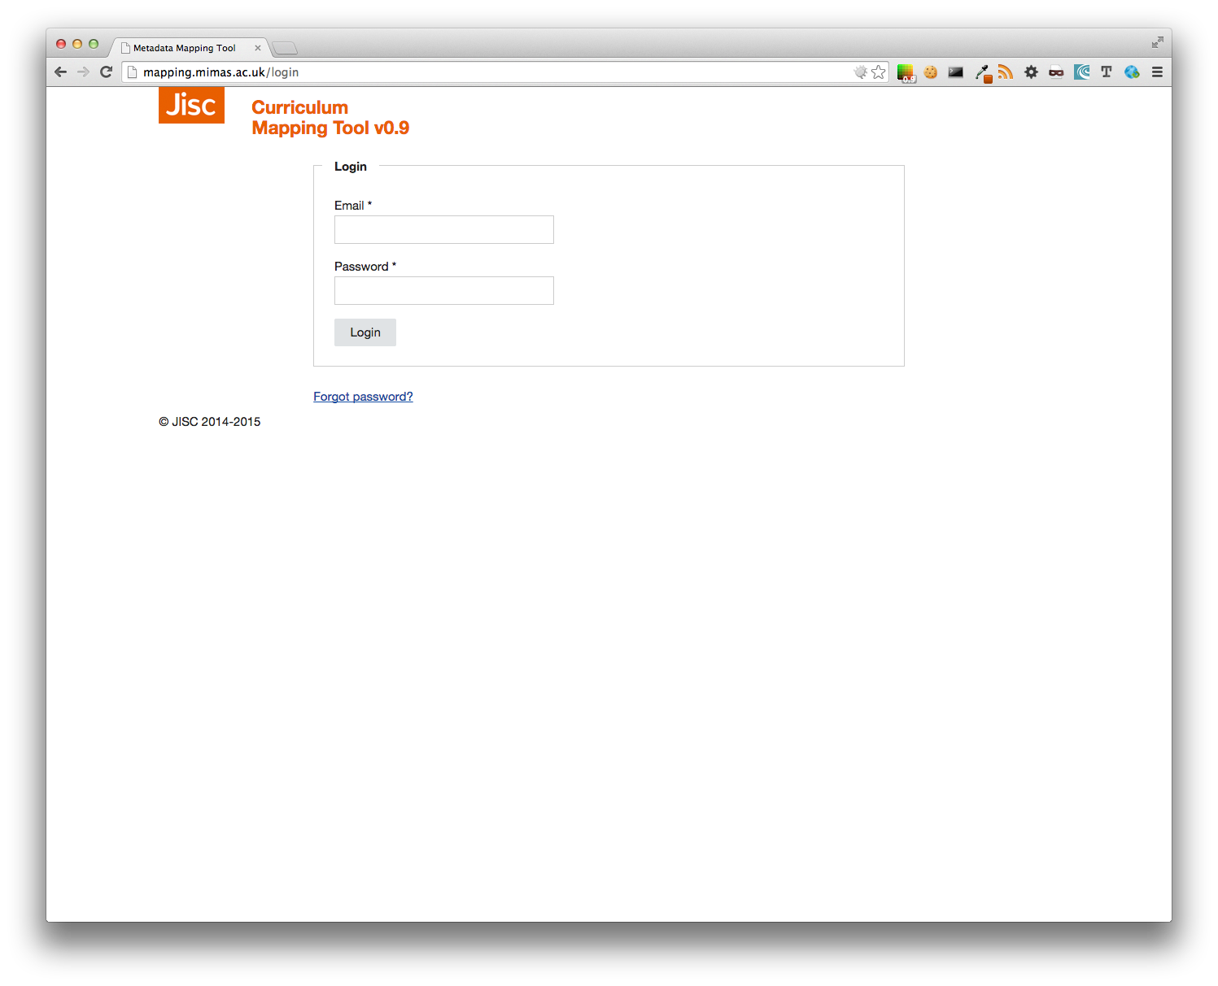

*Fig I: Login screen*

If you do not have an account please email [support@mimas.ac.uk] to request one. After logging in you will be taken to the Dashboard where you will see a VU meter showing progress, stats and links to download the mappings and other reports in various formats.[1] On the top right you will see the available options.

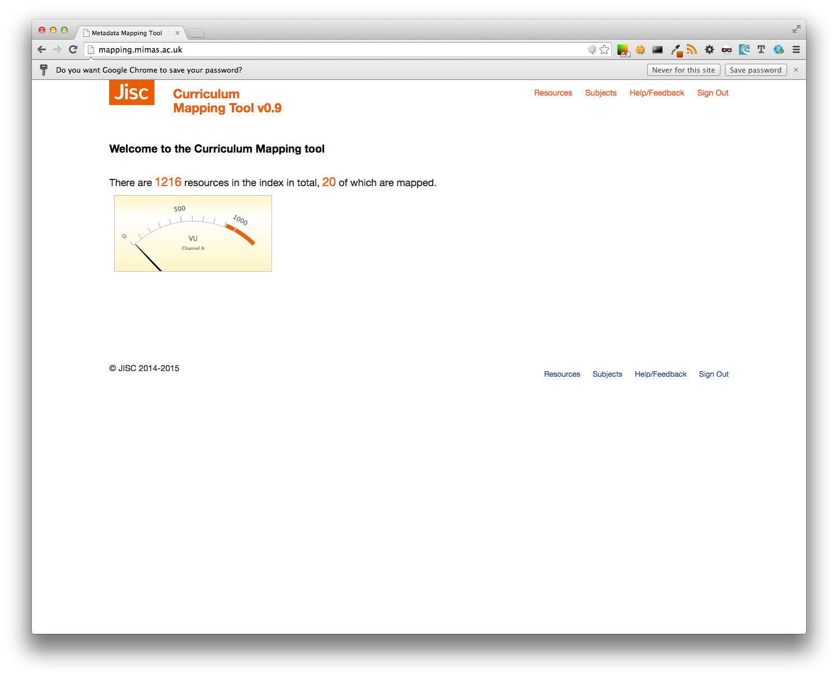

*Fig II: The Dashboard*

Please do note that not all options are available to all users. Typically a practitioner would only see links to the Resources, Sign out and Help/Feedback[2], see below.

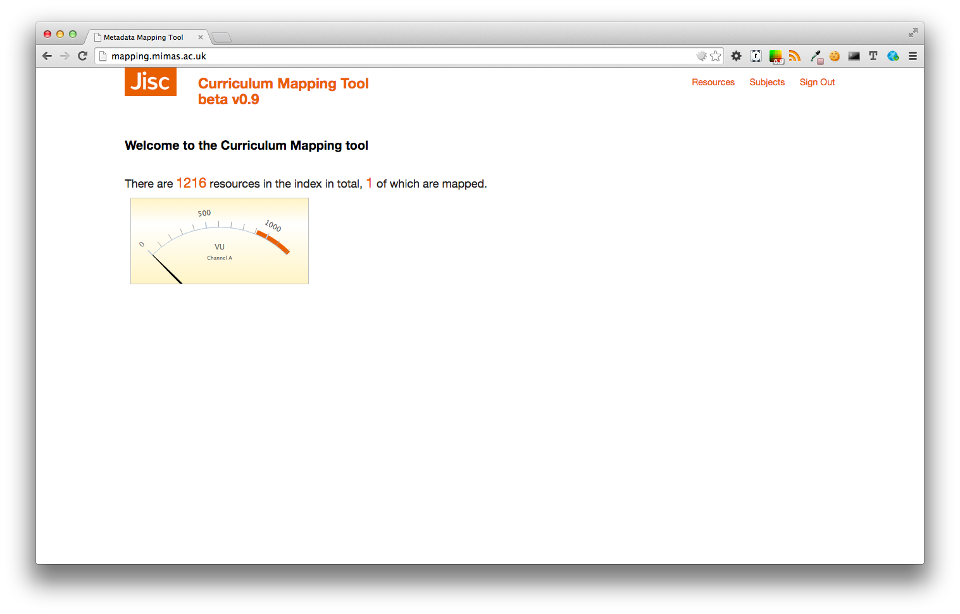

*Fig III: Typical Screen for practitioners.*

Everything happens under resources. Here you will be able to browse the various resources, perform searches, paginate and order the results.

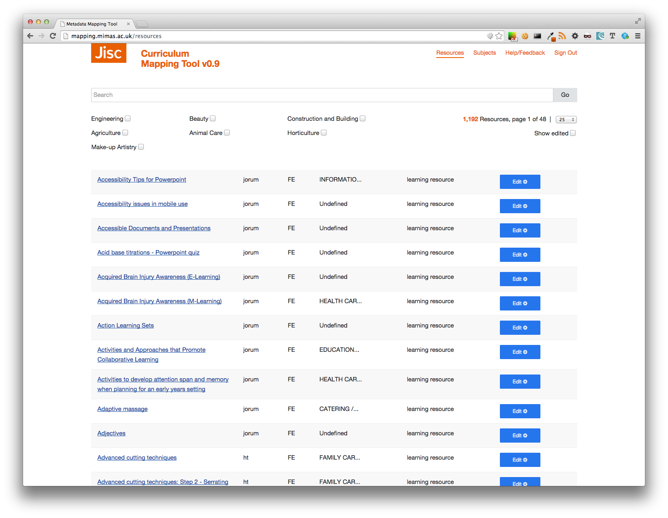

*Fig IV: The Resource browse page, with the various options.*

The browser page shows which resources have been mapped and which ones not. By default, resources that have been edited do not appear here, unless “Show edited” has been ticked.

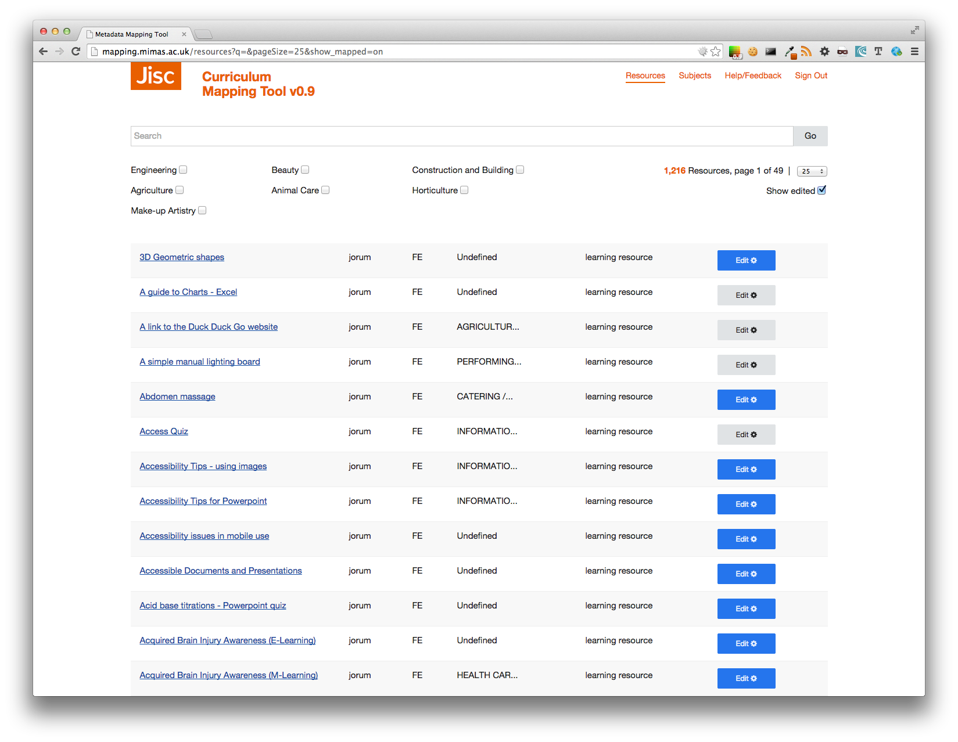

*Fig V: The Resource browse page, including the edited resources (grey buttons).*

Clicking on the title’s hyperlink you will be taken to the viewer, a page where you can easily see the various metadata associated with the resource, such as classification, as well as buttons allowing you to preview and download the attached media.

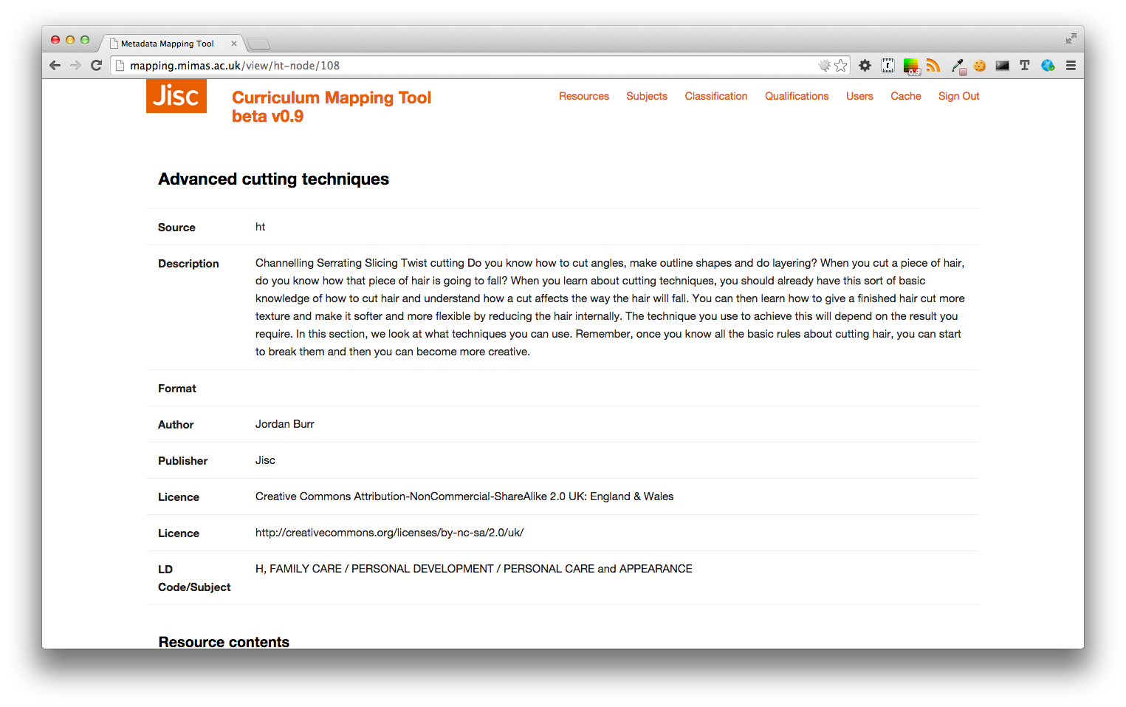

*Fig. VI: Viewing a resource.*

Scrolling down in the page you will get a list of the attached media files and links to preview and download them.

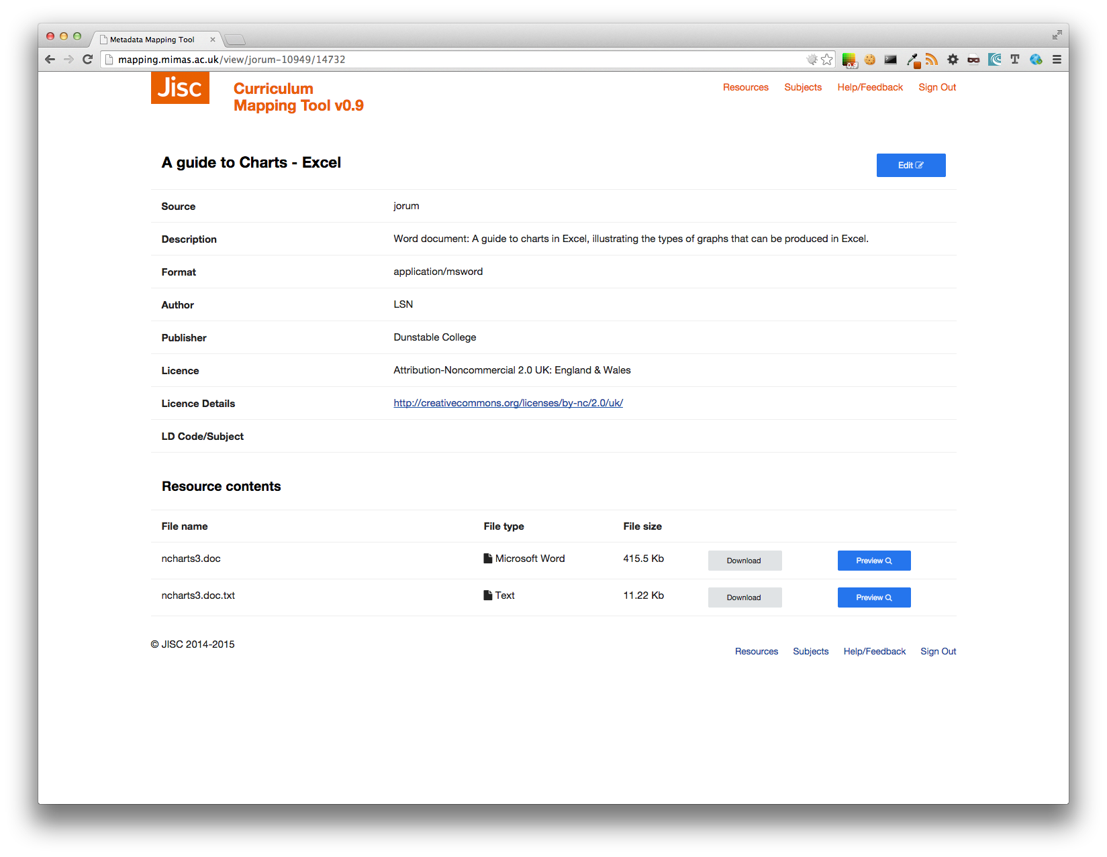

*Fig. VII: Download and preview media attached to a resource.*

Clicking on preview you should get a ‘popup’ window, showing the attached media. Clicking on the dark area surrounding area or hitting the ESC button the pop up closes and you will be directed back to your resource view.

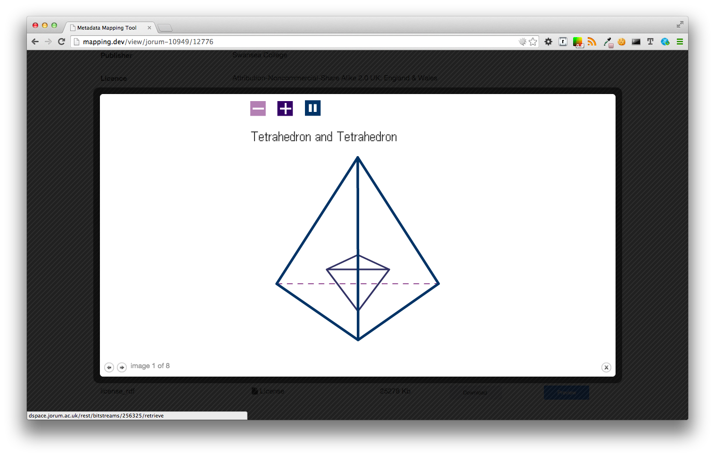

*Fig. VIII: Media preview (in this instance, a 3D Flash object).*

Supported media for preview include MS Office documents, Shockwave and Flash, external movies (e.g. Vimeo and Youtube), as well as standard documents, i.e. RTF, PDF, TXT and XML. In addition, external website previews are also supported.



*Fig. XIX: External Video preview*

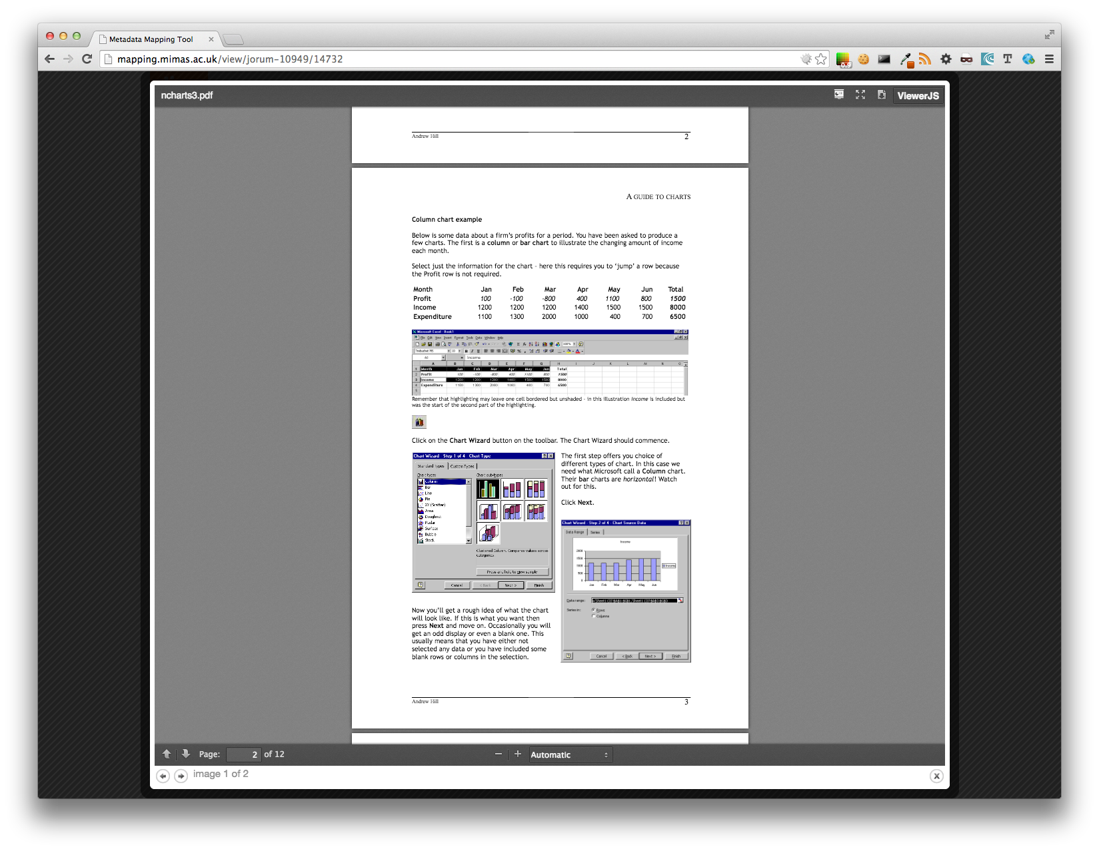

*Fig. XX: Microsoft Office preview (word in this instance)*

The following pages are the main working areas. If you click edit in the resource browser page you will be presented with the following screen.

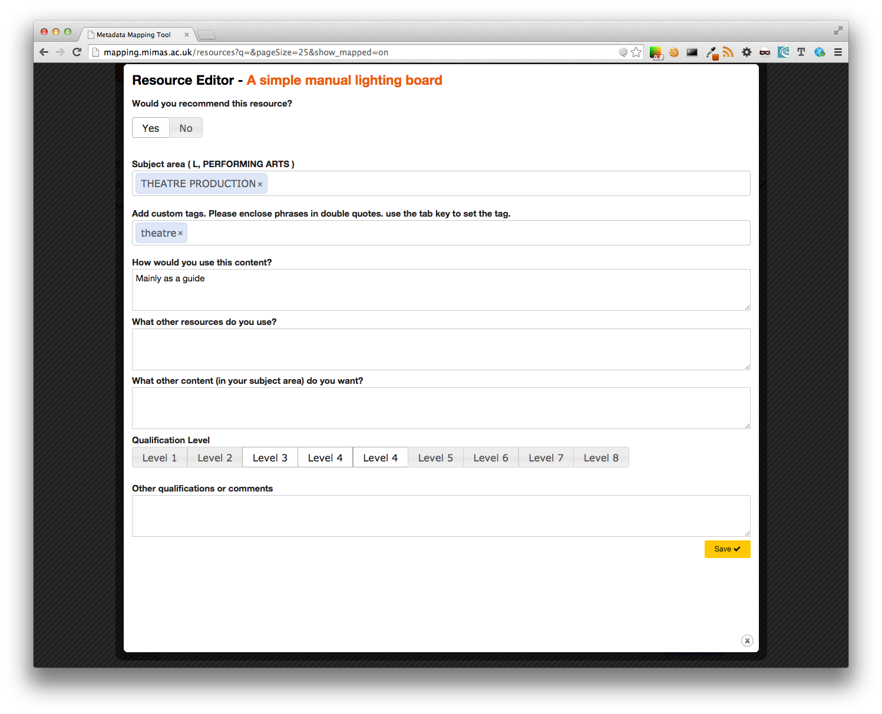

*Fig. XXI: Edit current resource (yes).*

If you think that this resource is current then complete the criteria below. Please not that simply focusing on the subject area textbox will bring automatically a pop up reflecting the subject area the resource belongs to. It might be the case that the resource is out of date, or that the main subject area is ambiguous.

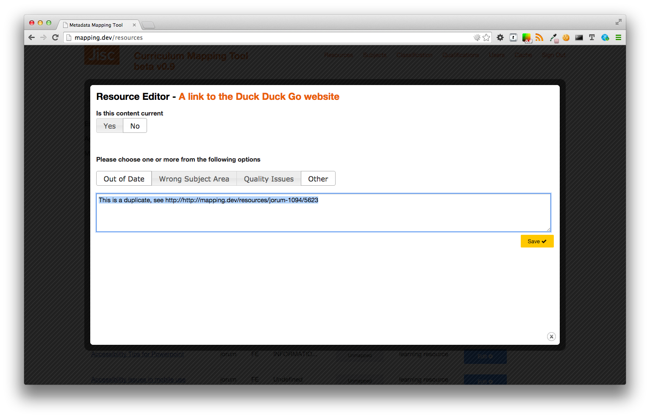

*Fig. XXII: Marking a Resource as not current.*

1. Not implemented as yet (20/10/2014). Should be there by 24/10/2014.
2. Will be available at Milestone 2, 06/11/2014.